1. How we generate random networks. Why do we compare things to random networks?
Network science aims to build models that reproduce the properties of real networks. Most networks we encounter do not have the comforting regularity of a crystal lattice or the predictable radial architecture of a spider web. Rather, at first inspection they look as if they were spun randomly. Random network theory embraces this apparent randomness by constructing and characterizing networks that are truly random.
Let us give the overlay of random networks.
G (N, L) Model
- N labelled nodes are connected with L randomly placed links.
G (N, p) Model
Each pair of N labelled nodes is connected with probability p, a model introduced by Gilbert
Hence, the G (N, p) model fixes the probability p that two nodes are connected and the G (N, L) model fixes the total number of links L. While in the G (N, L) model the average degree of a node is simply <k> = 2L/N, other network characteristics are easier to calculate in the G (N, p) model. We will explore the G (N, p) model, not only for the ease that it allows us to calculate key network characteristics, but also because in real networks the number of links rarely stays fixed.
Hence, the G (N, p) model fixes the probability p that two nodes are connected and the G (N, L) model fixes the total number of links L. While in the G (N, L) model the average degree of a node is simply <k> = 2L/N, other network characteristics are easier to calculate in the G (N, p) model. Throughout this book we will explore the G(N, p) model, not only for the ease that it allows us to calculate key network characteristics, but also because in real networks the number of links rarely stays fixed.
A random network consists of N nodes where each node pair is connected with probability p.
To construct a random network, we follow these steps:
1) Start with N isolated nodes.
2) Select a node pair and generate a random number between 0 and 1. If the number exceeds p, connect the selected node pair with a link, otherwise leave them disconnected.
3) Repeat step (2) for each of the N(N-1)/2 node pairs.
The network obtained after this procedure is called a random graph or a random network.
From a modelling perspective a network is a relatively simple object, consisting of only nodes and links. The real challenge, however, is to decide where to place the links between the nodes so that we reproduce the complexity of a real system. In this respect the philosophy behind a random network is simple: We assume that this goal is best achieved by placing the links randomly between the nodes
The probability that a random network has exactly L links is the product of three terms:
1) The probability that L of the attempts to connect the N(N-1)/2 pairs of nodes have resulted in a link, which is p^L
2) The probability that the remaining N(N-1)/2 - L attempts have not resulted in a link, which is
3) A combinational factor,
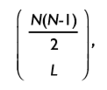
counting the number of different ways, we can place L links among N(N-1)/2 node pairs.

We can therefore write the probability that a particular realization of a random network has exactly L links as
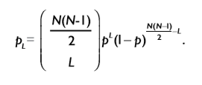
As the above-mentioned equation is a binomial distribution, the expected number of links in a random graph is
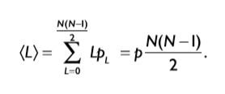
Hence <L> is the product of the probability p that two nodes are connected and the number of pairs we attempt to connect, which is Lmax = N (N - 1)/2
Using the expected number of links, we obtain the average degree of a random network
Hence <k> is the product of the probability p that two nodes are connected and (N-1), which is the maximum number of links a node can have in a network of size N.
In summary the number of links in a random network varies between realizations. Its expected value is determined by N and p. If we increase p a random network becomes denser: The average number of links increase linearly from <L> = 0 to Lmax and the average degree of a node increases from <k> = 0 to <k> = N-1.
A random network framework where the different networks are samples from the same probability distribution may be useful for examining such questions. Without any restrictions, a random network model is very high-dimensional, but one can make tractable random network models through various simplifications.
One advantage of looking at an ensemble of networks defined by a probability distribution is that we can zero in on the influence of different statistical properties. We can imagine taking many samples from the probability distribution and look for properties that are common to most of the samples. In some cases, we might be able to take an ensemble average of a quantity, where we take an average over the probability distribution.
Besides the mathematical convenience, in many cases, looking for properties over a whole network ensemble makes sense in a real world application. For example, despite the fact that people's brains are wired differently, most people are able to perform similar motor tasks, such as picking up an object. If we want to discover the network properties that facilitate such an action, we might not be interested in the network variations among individuals but the features that are common among the individual. A random network framework where the different networks are samples from the same probability distribution may be useful for examining such questions.

Top Row
Three realizations of a random network generated with the same parameters p=1/6 and N=12. Despite the identical parameters, the networks not only look different, but they have a different number of links as well (L=10, 10, 8).

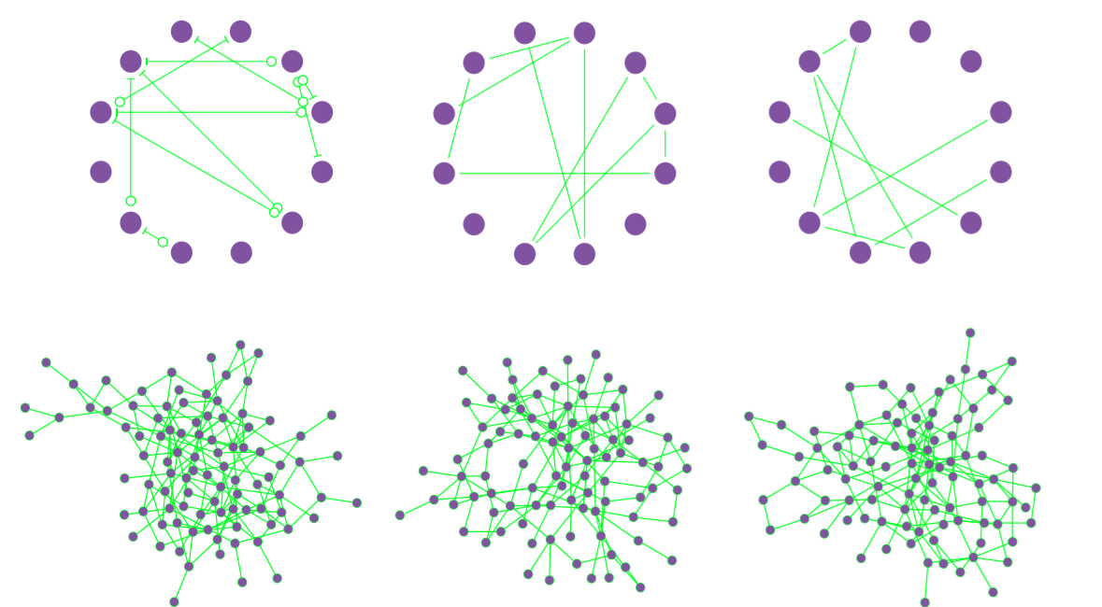
Bottom Row
Three realizations of a random network with p=0.03 and N=100. Several nodes have degree k=0, shown as isolated nodes at the bottom.
The dimension of random networks
For a random network, the random variables are the entries of the adjacency matrix. These entries are 0 or 1, depending on whether or not the corresponding edge exists, so the probability distribution is similar to the previous one mentioned above. The dimension of the parameter space describing the probability distribution will be 2^n−1 if we have n different random variables.
If we have a network of N nodes, then the adjacency matrix is an N×N matrix. This matrix has N^2 entries, but if we exclude self-connections and make the network undirected, then there are only N^(N−1)/2 unique entries in the matrix. The probability distribution describing the resulting random network will be in terms of n=N(N−1)/2 different Bernoulli random variables. The dimension of the parameter space is 2^(N(N−1)/2-1.
Therefore, to determine a probability distribution defining an N×N unweighted and undirected random network, we just need to pick 2^N(N−1)/2 different positive numbers (making sure they are all really small so that there sum is no larger than one). For each possible combination of these 2N(N−1)/2−1 different numbers, we have a different probability distribution, hence a different random network model.
Let's say we have a network of N=3 nodes, then we have to pick 2^(3⋅2/2)−1=2^3−1=7 different numbers to specify the network probability distribution. Increasing the network size to N=5 nodes, and the dimension of the parameter space increases to 2^10−1=1023. These numbers are getting large fast. If we stay with tiny networks and just increase the size to N=10 nodes, the dimension of the parameter space jumps to 2^45, which is over 35 trillion. Increase the size to a small network of N=100, and we have to choose over 10^1490 different parameters. We won't even think of what happens if you go beyond a medium size network of N=1000, where the parameter space weighs in at over 10^150,364 dimensions. Given that the number of atoms in the observable universe is estimated to be around 10^80, it's hard to comprehend the size of this number of dimensions.
Reducing the dimension
To develop tractable random network models, it's clear we have to shave off a few dimensions from the parameter space describing the network probability distribution. Otherwise, it will take us awhile to come up with the 10^150,364 number describing the probability distribution for a network of N=1000 nodes.

Statistical homogeneity
In our above calculation, we made the probability distribution completely general. In particular, we allowed all 1000 nodes to be completely different. A dramatic simplification will be to assume that all 1000 nodes are statically identical, or that the network is statistically homogeneous. In other words, we can insist that the probability distribution does not change if we switch the order of the nodes. If we switch node one and node two, we want to make sure that the table of probabilities does not change.
For N nodes, there are N!=N(N−1)(N−2)⋯1 different orderings of the nodes. So it seems we could reduce the size of the dimension by a factor of N! if we insist the probabilities don't change by any reordering. (It actually does not reduce it by quite this much due to complicated symmetries, but let's not worry about this.) Let's say the dimension of the parameter space for NN nodes is reduced to 2^(N(N−1)/2)/N!.
The factorial N! increases very rapidly with N, so dividing by N! should help keep the dimension down. When N=1000, N! is an astronomically large value of around 10^2567. But, unfortunately, 2^(N(N−1)/2) grows much faster. Dividing by N! only reduces the dimension from around 10^150,364 to the not-so-small number of 10^147,797.
Enforcing statistical homogeneity on the network was not nearly enough to make the dimension tractable. The possible network structures are just too complicated. We need to do something much more drastic to obtain a workable random network model.

Independence
One simplification that will immediately bring down the dimension of the probability distribution parameter space is to assume that the random variables are independent. If the random variables Xi are independent, then we can factor the probability distribution of the vector X= (X1, X2,…,Xn) into many probability distributions for a single variable,
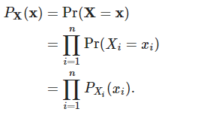
This description is much simpler. If we assume that each random variable
Xi is a Bernoulli random variable, then we need just one parameter (the probability pi that it is 1) to determine the probability distribution PXi(xi):
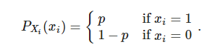
For the probability distribution of the n variables in X, we just need n different parameters, way less than the 2n−1 we needed without the independence assumption.
This assumption makes it tractable to write down a probability distribution even for large networks. For an undirected network of N nodes, we will have n=N(N−1)/2n independent Bernoulli random variables corresponding to each possible location for an edge. We'll need to pick just N(N−1)/2 parameters (the probabilities pij that there is an edge between each pair of nodes i and j). If N=1000, this is 499,500 different numbers, a few less than 10^150,364 we had earlier.
Still 499,500 is still a bit large. We can reduce this further by assuming statistical homogeneity, which in this case is assuming the probability pij of an edge does not depend on the node labels i and j. Now we just need to pick a single parameter pp, the probability that any edge exists. We have reduced the parameter space down to one dimension!
What we've come up with is the Erdös-Rényi random network model, the simplest type of random network model. This model is so natural, that people often refer to these networks as simply “random networks,” and may view deviations from the Erdös-Rényi model as “non-randomness. “
This model stays one-dimensional even if we extend it to directed graphs and is easy to generate. We can also extend the model to populations of different types of nodes, allowing the probability of a connection to depend on the populations of the nodes involved. As long as we keep the independence assumption, the model is easy to understand, and it is a simple matter to generate the networks.

Random graphs are used not because all the properties of networks are described by its parameters, like distribution of links, length of the longest connected set, but because the number of possible networks is enormous and because we need to cluster them in types. For each type (here random network with certain properties) we can simulate some social interaction. A big question still remains what part of interaction can be described by random network parameters and what part by its particular realization. Statistics will just tell us that the rest is random noise. But the difference from other statistical applications is that origin of network is not essentially random. For every social application (propagation of diseases, propagation of gossips, etc) the separation of social outcome into explained and random component may differ. But still this is the best we can do. In fact, we often cannot measure all topological structure of real network and have to derive result based on approximate values and topology.
Similarly, if you have a real life network you can learn a lot by comparing it to a random network - but a relevant random network, namely one that has the same mean connectivity for example (i.e. each node has the same number of neighbours on average). For example, in a social network the number of triangles is consistently higher than in a random network with the same number of links per site. This corresponds to the fact that if you have two friends it is likely that they will be friends too. This insight is not huge but it captures something important regarding social networks, that your exposure to new people is mediated by your existing social links and not created at random - you get to know new people usually because someone you know already knows them. This is just an example - but I hope you see where it is going.
The main issue is matching your real-world network with a relevant random graph, technically speaking, with a proper null-model. A quite general framework is provided by the so-called "the configuration model", namely an ensemble of random graphs that realize a certain degree distribution. In other words - I think that if you compare your real-life network with a random network with the same degree sequence for a certain property you can learn how probably certain features are.

Reference
- A random graph generation algorithm for the analysis of social networks James F. Morris, Jerome W. O’Neal, and Richard F. Deckro
- Revisiting the Small-World Phenomenon: Efficiency Variation and Classification of Small-World Networks
Tore Opsahl1, Antoine Vernet2, Tufool Alnuaimi2, and Gerard George
- Network Science Random Networks Barabasi
- https://mathinsight.org/absurd_high_dimensionality_random_graphs

